**AFRL Research Collaboration Program**

**Contract FA8650-13-C-5800**

**Effect of Constituents and Microstructure on Energy Dissipation Mechanisms During Damage Growth**

**University: Texas A&M University**

1. **PROJECT TEAM MEMBERS**
2. **LEAD UNIVERSITY POC:** John Whitcomb, 979-845-4006, jdw@tamu.edu
3. **PROJECT TEAM MEMBERS:** John Whitcomb, Collin Blake
4. **AFRL TECHNICAL POC:** Craig Przybyla
5. **TECHNICAL DISCUSSION**
6. **CURRENT WORK**Development of the infrastructure to perform mesoscale analysis of 3D textile composites.

**Background**

The wide use of woven textiles in industry has created an interest for realistic computational modeling of woven textile fabrics. VTMS is a software developed by Eric Zhou at the Air Force Research Lab in Dayton, Ohio that creates complex woven geometry. The process is documented in published papers[1][2] and is outlined in Figure 1.

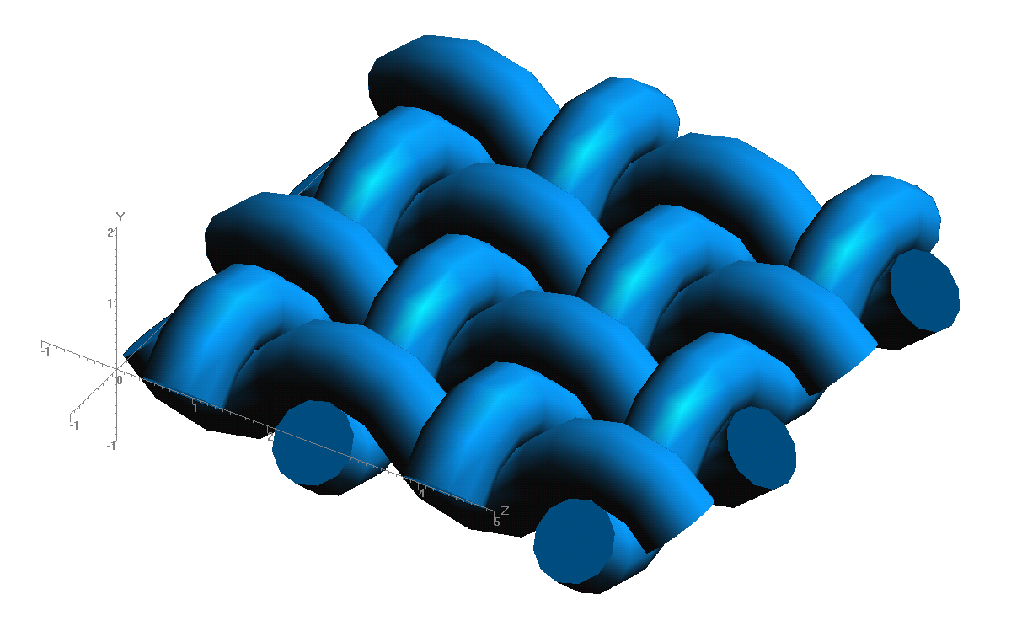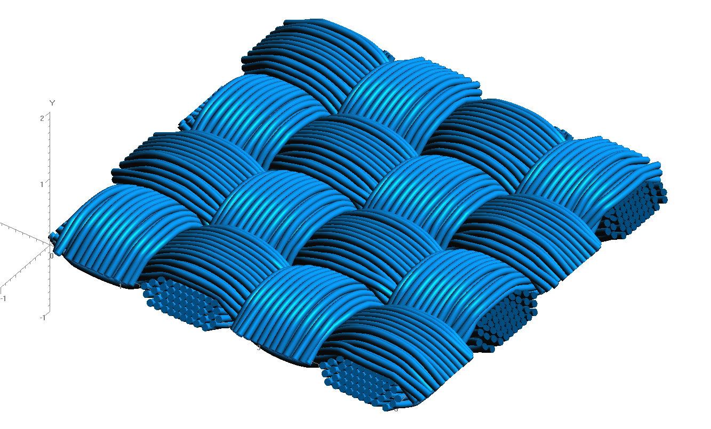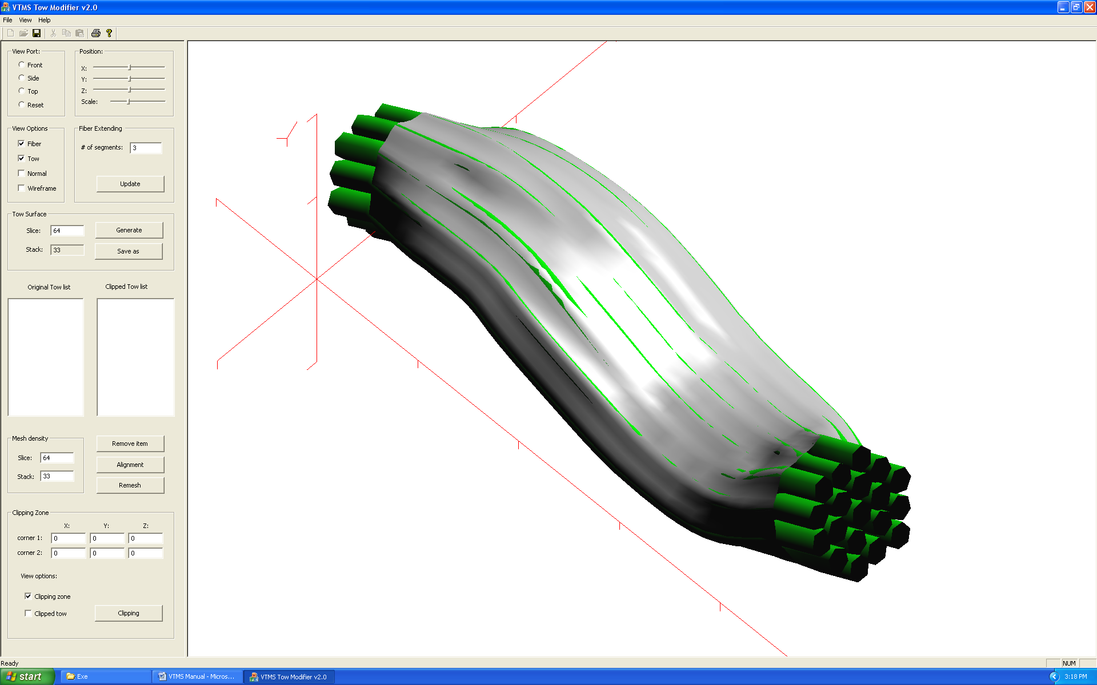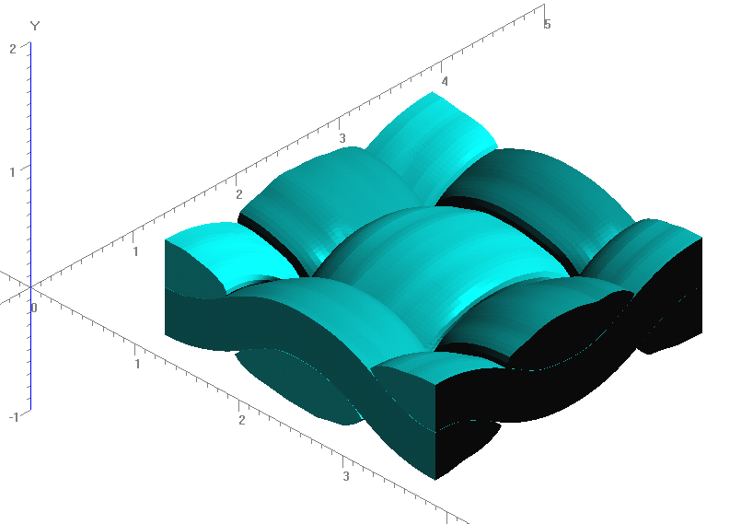

**Figure 1: Evolution of Weave Tow Geometry**

**a) Generic Approximation of Woven Pattern**

**b) Filament Representation of Pattern**

**c) Surface Approximation of Filament Bundles**

**d) Volume Model Derived from Surfaces**

This work focuses on the result of approximating the surface of a woven filament bundle as a surface mesh (Figure 1.c shows a highly refined mesh). The resulting surface approximations can and often do have regions where the surface approximations, represented as polygons, intersect and create regions of interpenetrations. This is both physically impossible, as two volumes cannot share the same space, and computationally impossible to use in traditional finite element analysis software. Therefore, the interpenetration regions must be resolved before the simplified surface models can be used in analysis.

**[1] Youqi, W.; Sun, X. “Digital-element simulation of textile processes.” *Comp. Sci. and Tech.* 2000, 61, 311-319.**

**[2] Maio, Y.; Zhou, E.; Wang, Y.; Cheeseman, B. A. “Mechanics of textile composites: Micro-geometry.” *Comp. Sci. and Tech.* 2008, 68, 1671-1678.**

**Approach**

The interpenetrating elements must first be identified before they can be fixed. The surfaces and interpenetrations needed to be visualized before the problem could be solved. Multiple methods were developed to visualize VTMS surfaces in a visualization software called Paraview. This software offers more functionality when viewing this data than either the default VTMS software or any in-house software. The surfaces are created by systematically creating triangular surface elements using the VTMS surface points. The result is a triangulated surface representation of each filament bundle. Using this software, the surfaces and their interpenetrations were more easily visualized and understood. Figure 2 shows two surfaces that have been visualized using Paraview.

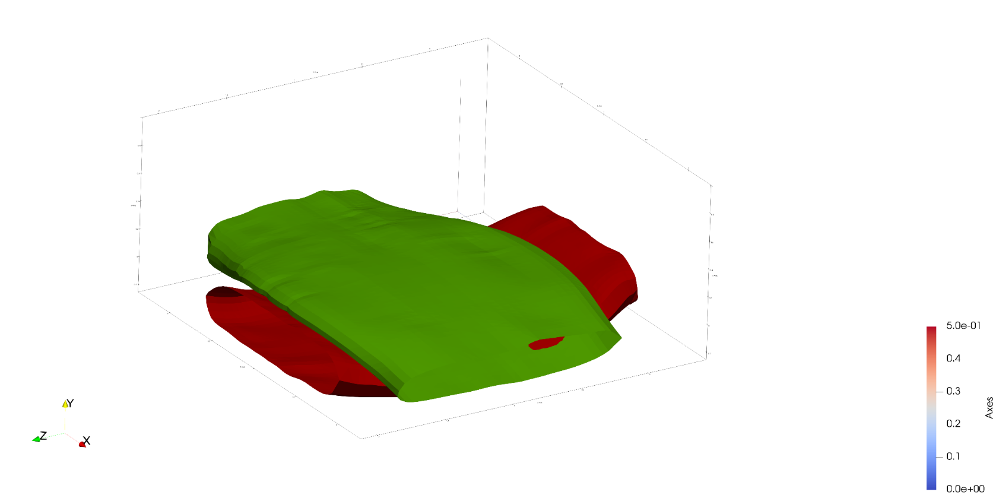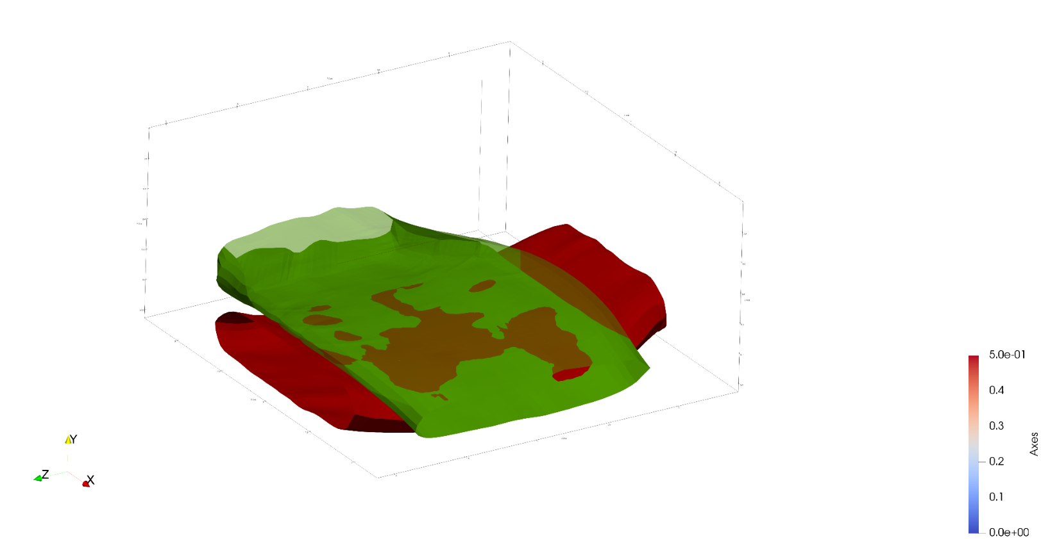

1. **Transparent upper tow showing interpenetrations**
2. **Tows in close proximity**

**Figure 2: Region of close tow geometries with interpenetrations**

Multiple attempts were made to use the polygonal surface given by VTMS directly to identify the interpenetrating elements. However, all the methods that were created were not robust enough to ensure accurate identification. The problem of defining where two surfaces intersect is not new and significant literature exists on identifying regions of intersection using Non-Uniform Rational B-Spline (NURBS) surfaces. NURBS use piecewise polynomial curves connected to represent a surface or shape in up to three dimensions as one continuous surface. However, the surface provided by VTMS is not continuous but instead constructed from polygons. Therefore, the surface needed to be described as a continuous surface to use methods developed in literature. The SISL library developed by the Geometry Group at SINTEF ICT, Department of Applied Mathematics was used to help solve this problem.

The SISL library provides two main functions. First, the library is used to fit a NURBS surface to the point data given by VTMS. The original surface points do not lie perfectly on the resulting surface because the NURBS surface is an approximation of the surface the points define. Figure 3 shows this relationship. Figure 3 also shows that the NURBS surface fits to the points well as an approximation, nearly intersecting with every point shown in the cross-section.

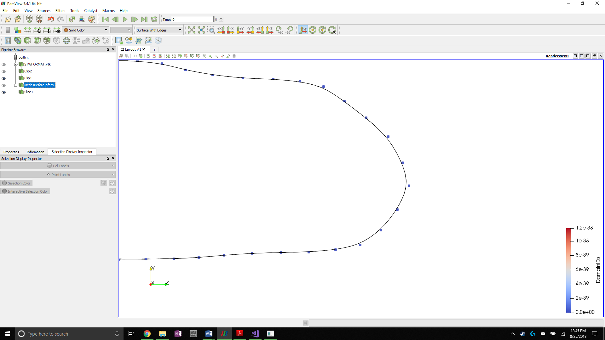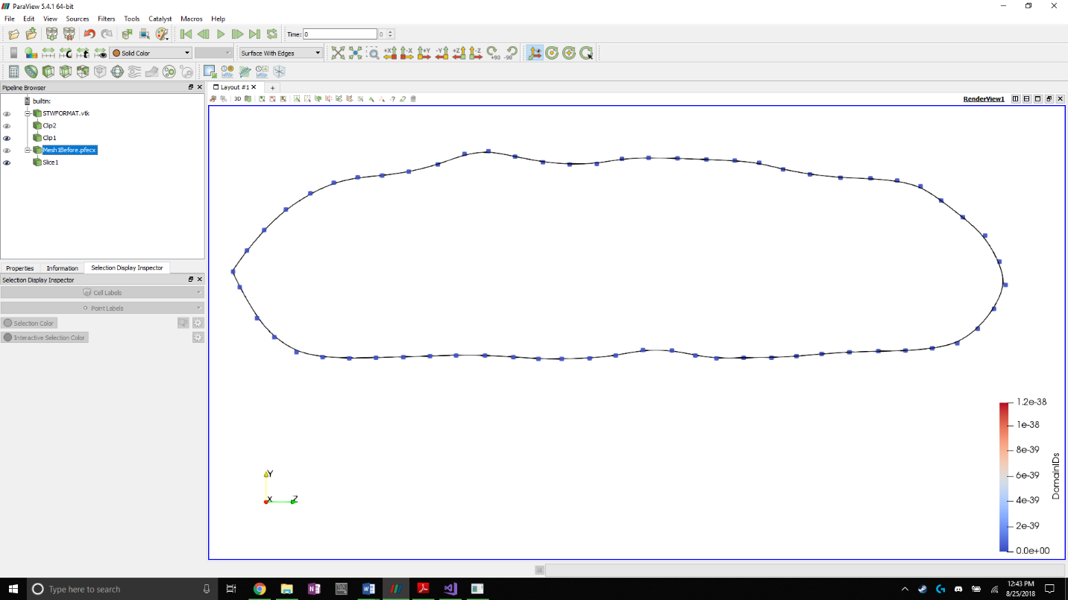

**Figure 3: NURBS approximation of tow cross section with original VTMS data as control points**

The second function of the library is to identify the intersection between the two surfaces. The intersection curve between the two surfaces is also the boundary curve for the interpenetration region of the surfaces, outlining where the interpenetration region lies. Figure 4 shows the outline of all interpenetration regions from figure 2. The curves shown are piecewise linear approximations of the b-spline intersection curves that the library returns. When the intersection curve is overlaid onto the surface, it is used to determine which elements are the interpenetrating elements. The NURBS surface is visualized by creating a triangulated surface from points that lie directly on the NURBS surface. These points are found by using a function in the SISL library that returns the coordinates of a point on the surface. This function is used to create a uniformly distributed set of points to create the visualization. The more points that are used, the better the visualized surface represents the actual surface.

Once the intersection curves are verified to be unique and closed, an algorithm determines where a curve intersects a surface element edge. The intersection points between the curve and the surface elements are calculated for each surface and stored. These points are vital to ensuring that the intersection curves are compatible with each surface. This compatibility with each surface also results in the intersection curve becoming the line along which the tow surfaces can share compatibility with each other. Once the intersection points from both surfaces are collected, the remaining points of the linearly approximated b-splines are removed to create a curve that has the approximate shape of the original intersection curve. This process serves to reduce the refinement of the intersection curve (high refinement causes issues with element shape and density along the intersection curve) when the curve is used to divide and mesh surface elements intersected by the boundary curve. Once a curves refinement is reduced, the intersected elements are re-meshed to include any part of a curve that lies within the boundaries of the surface element. Figure 5 shows an original intersection curve and the reduce refinement representation of the curve with the surface elements re-meshed.

**Figure 4: Linear approximation of intersection curves overlaid on triangular surface approximation of NURBS surface**

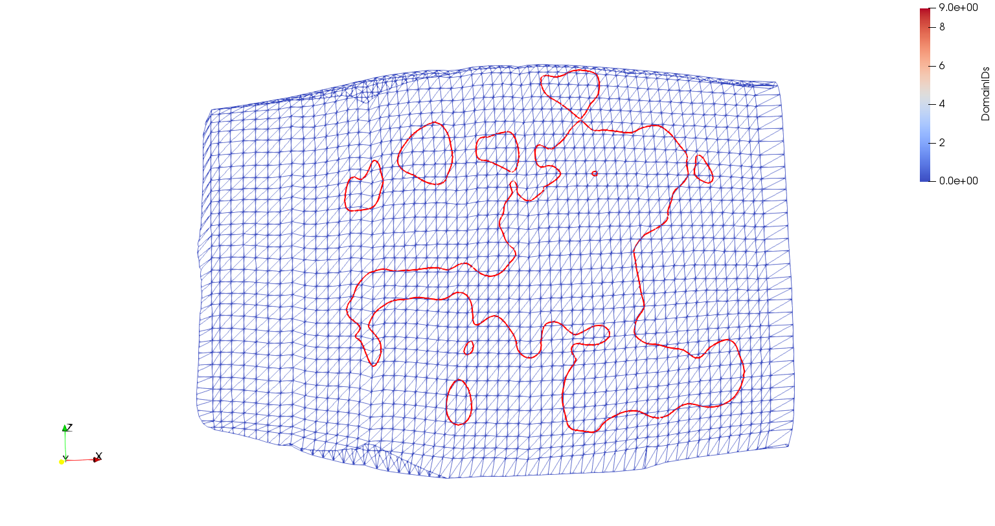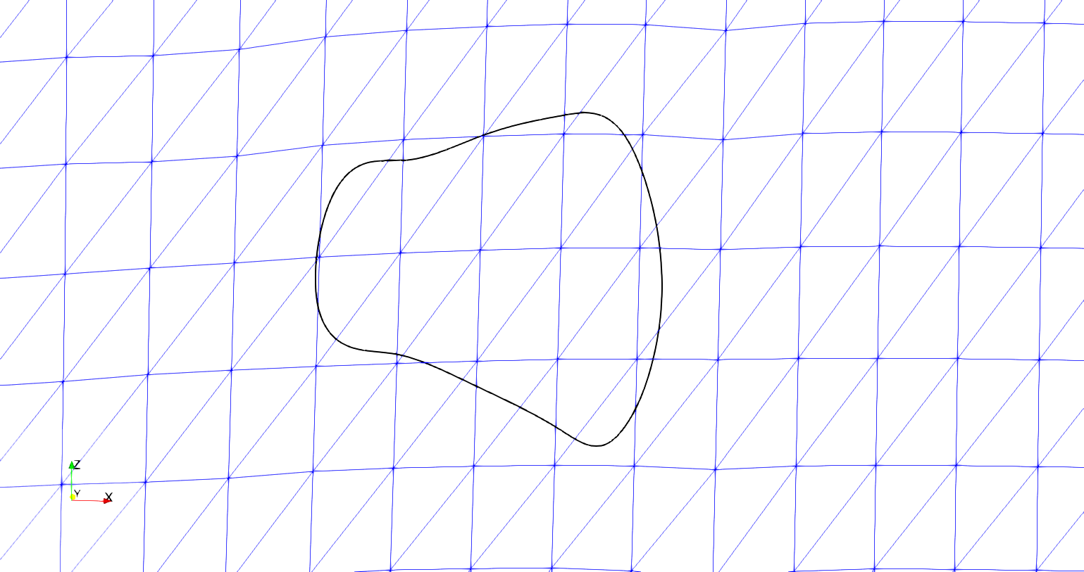

**Figure 5: Original linear approximation of intersection curve and reduced refinement representation**

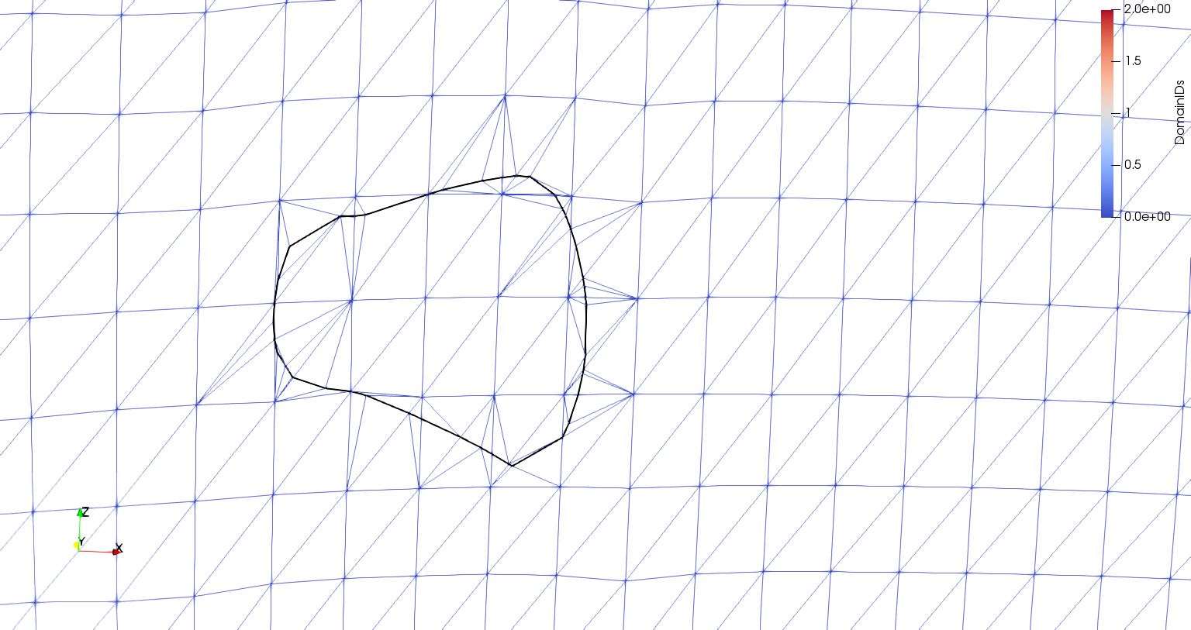

Figure 6 shows how the reduced refinement curves compare to the curves in Figure 2. Having the intersected elements re-meshed allows for any original surface elements that were only partly contained by the intersection curve to have that section removed without affecting the rest of the element. Only removing the necessary section of the surface element allows the interpenetrations to be fixed while minimally affecting the surface. Once all the intersected surface elements have been re-meshed, the last step is to remove any elements that lie inside of the intersection curve.

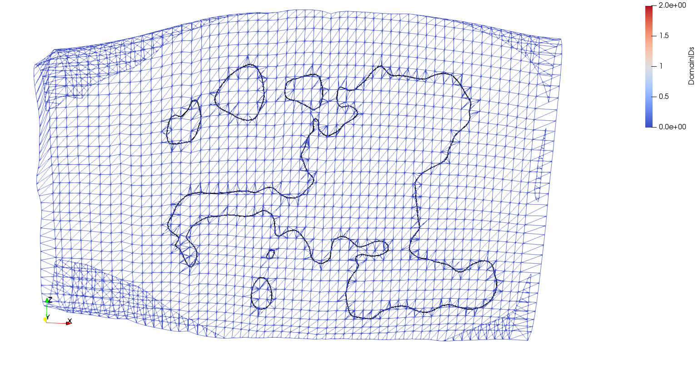

**Figure 6: Surface mesh after dividing surface elements by the intersection curve**

1. **CONCLUSIONS/ANALYSIS TO DATE**

The strategy is robust thus far. The routines have no issues dividing and re-meshing the surfaces using the intersection curve. There still exists some elements that are smaller and more badly shaped than preferred. However, these elements still allow an analysis to be conducted and therefore will suffice for the purposes of this research. Future development will address the issue of fixing these elements.

**WORK FORECAST AND PLANS**The final step is to properly remove any elements inside of the intersection curve and replace them with a set of elements that will be shared between the surfaces. It is expected that a ray-intersection between the centroid of an element and the intersection curve will identify the elements to be removed. Then one set of removed elements will become the replacement set for both surfaces, creating a compatible region of elements between the two surfaces. This compatibility is required to run a traditional finite element analysis. Once this proof of concept approach has been successfully tested, other means of creating a compatible mesh region between the two surfaces will be explored.